Project Plan Document
Table of Contents
- Project Scope
- Project Organization
- Objectives
- Key Phases and Timeline
- Resource Planning
- Risk Management
- Communication Plan
- Change Management Plan
- Budget Plan

Writers
- Tenay Giray
- İpek Atak
- Defne Saracel
- Nehir Adak

Project Scope: We will use simple rating scale and a score-based rating. We will not use AI based feedback system.
Project Organization:
Project Manager (Changes every sprint): directs weekly process
Frontend Developer: responsible for user interface
Backend Developer: responsible for database management
Tester: tests the current version of the software
Objectives: We are planning to have weekly sprints and committing our weekly progress to GitHub so we can lead the process systematically. Also at the beginning of the process we will allocate time for learning required software tools such as “Flutter” and chosen database cloud system.
Key Phases and Timeline:
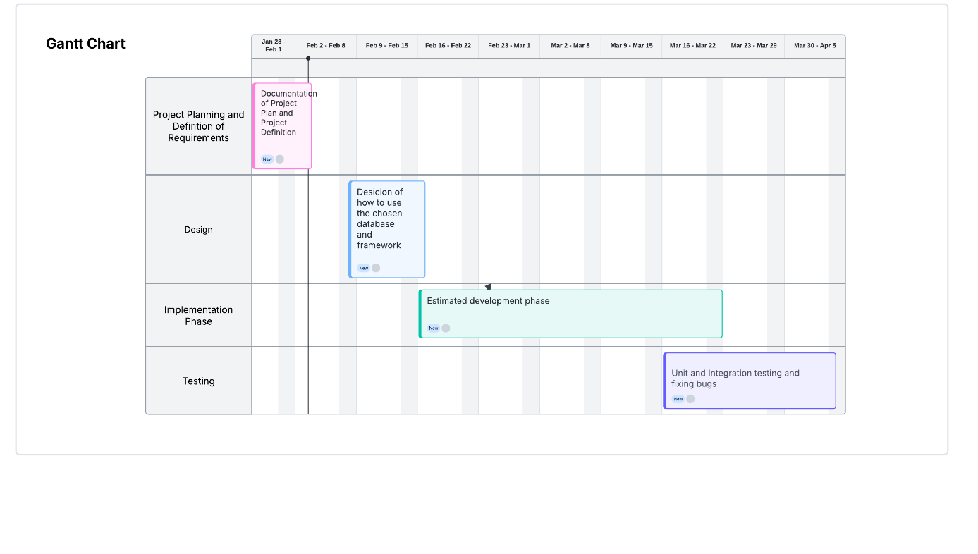
Resource Planning: We will be using free resources. Flutter as our Software Development Kit, free cloud database system. For communication Zoom and WhatsApp.
Risk Management: After unexpected events that cause delays we will have a quick brief then we will reschedule. If we encounter a software problem we will be reaching for help from online resources. If a team member cannot finish their part on time the rest of us will help with that part.
Communication Plan: Weekly 20 minute face-to-face meetings and if needed zoom meetings.
Change Management Plan: Firstly, we will define the requirements that need to be implemented. Then, we are going to hold a brief meeting to discuss how we can manage this change. Finally, we are going to update our action plan according to the changing requirements.
Budget Plan:
Definition of Requirements (%10): The effort will be focused on understanding the requirements and preparing the Requirements Document.
Design (%10): In this phase we will be focusing on designing the pathway that we are going to use while we are implementing the software.
Implementation Phase (%50): This phase will take the most effort because of the exhaustive development process. In that phase our team members will be working together on the tasks.
Testing (%30): The effort will be focused on unit and integration testing and fixing bugs. We will also check If the requirements are met.
Task Matrix
In this document we collaborate through all tasks while we are creating the contents.
- Tenay Giray | - Key Phases and Timeline, Risk Management, Scope
- İpek Atak | - Key Phases and Timeline, Budget Plan, Change Management Plan
- Defne Saracel | - Key Phases and Timeline, Objectives, Resource Planning
- Nehir Adak | - Project Organization, Communication Plan

